SQL Set Operators

🌟 Definition
# Source: AI Source: Provided by: [Data Path: Persons Table -> ID Column: 1, Name_En Column: Motasem Essam] -> From: [ChatGPT] on [6/11/2026]
SQL Set Operators are used to combine the results of two or more SELECT statements into a single result set.
Each SELECT statement must return:
- The same number of columns
- Columns in the same order
- Compatible data types
Set operators work on the result sets, not directly on tables.

🎯 Purpose
# Source: AI Source: Provided by: [Data Path: Persons Table -> ID Column: 1, Name_En Column: Motasem Essam] -> From: [ChatGPT] on [6/11/2026]
SQL Set Operators are used to:
- Combine data from multiple tables
- Remove duplicate rows
- Find common records
- Find different records
- Merge query results

🧠 Simple Example
# Source: AI Source: Provided by: [Data Path: Persons Table -> ID Column: 1, Name_En Column: Motasem Essam] -> From: [ChatGPT] on [6/11/2026]
Customers2024
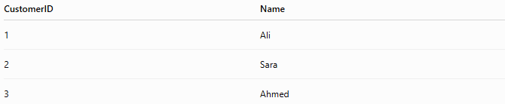
CustomerID | Name
1 | Ali
2 | Sara
3 | Ahmed

Customers2025
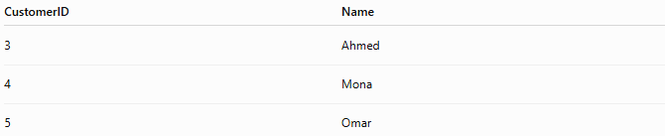
CustomerID | Name
3 | Ahmed
4 | Mona
5 | Omar

Using UNION:
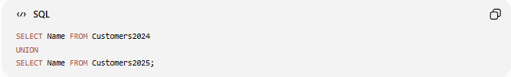
SELECT Name FROM Customers2024
UNION
SELECT Name FROM Customers2025;
Result
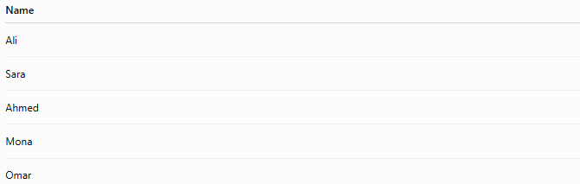
Name
Ali
Sara
Ahmed
Mona
Omar
Duplicate rows (Ahmed) appear only once.

📝 Rules for Set Operators
# Source: AI Source: Provided by: [Data Path: Persons Table -> ID Column: 1, Name_En Column: Motasem Essam] -> From: [ChatGPT] on [6/11/2026]
Before using set operators:
- Both queries must return the same number of columns.
- Corresponding columns must have compatible data types.
- Column names in the result come from the first SELECT.

🔢 Types of SQL Set Operators
# Source: AI Source: Provided by: [Data Path: Persons Table -> ID Column: 1, Name_En Column: Motasem Essam] -> From: [ChatGPT] on [6/11/2026]
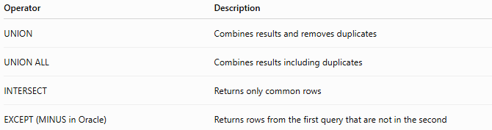
Operator | Description
UNION | Combines results and removes duplicates
UNION ALL | Combines results including duplicates
INTERSECT | Returns only common rows
EXCEPT (MINUS in Oracle) | Returns rows from the first query that are not in the second

1️⃣ UNION
# Source: AI Source: Provided by: [Data Path: Persons Table -> ID Column: 1, Name_En Column: Motasem Essam] -> From: [ChatGPT] on [6/11/2026]
Combines two result sets and removes duplicate rows.
Syntax
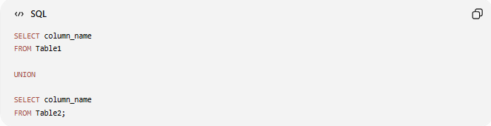
SELECT column_name
FROM Table1

UNION

SELECT column_name
FROM Table2;

Example
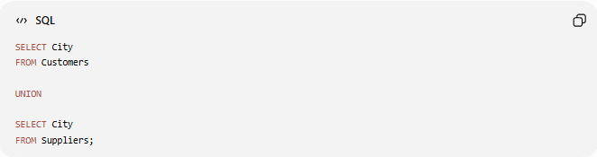
SELECT City
FROM Customers

UNION

SELECT City
FROM Suppliers;

Result
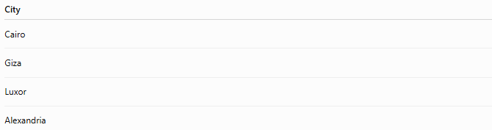
City
Cairo
Giza
Luxor
Alexandria
Each city appears only once.

2️⃣ UNION ALL
# Source: AI Source: Provided by: [Data Path: Persons Table -> ID Column: 1, Name_En Column: Motasem Essam] -> From: [ChatGPT] on [6/11/2026]
Combines two result sets and keeps duplicate rows.
Syntax
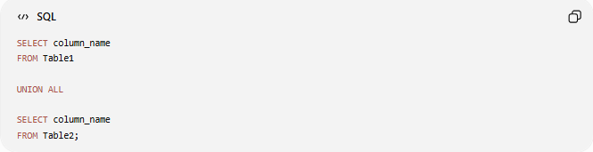
SELECT column_name
FROM Table1

UNION ALL

SELECT column_name
FROM Table2;

Example
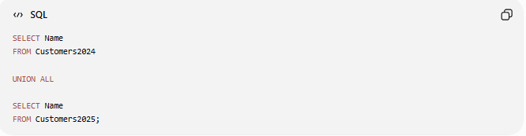
SELECT Name
FROM Customers2024

UNION ALL

SELECT Name
FROM Customers2025;

Result
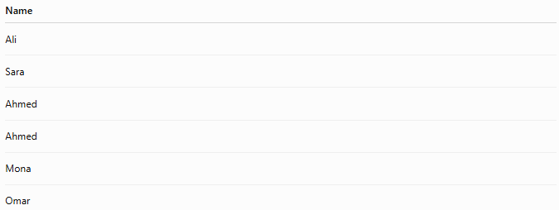
Name
Ali
Sara
Ahmed
Ahmed
Mona
Omar
Duplicate values are preserved.

3️⃣ INTERSECT
# Source: AI Source: Provided by: [Data Path: Persons Table -> ID Column: 1, Name_En Column: Motasem Essam] -> From: [ChatGPT] on [6/11/2026]
Returns only the rows that exist in both result sets.
Syntax
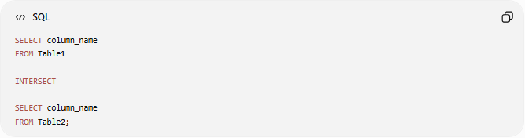
SELECT column_name
FROM Table1

INTERSECT

SELECT column_name
FROM Table2;

Example
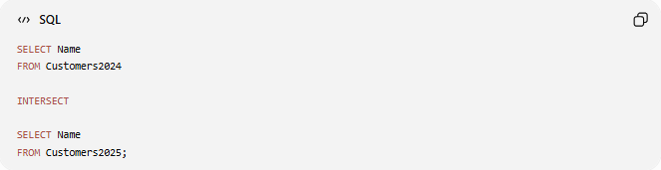
SELECT Name
FROM Customers2024

INTERSECT

SELECT Name
FROM Customers2025;

Result
Name
Ahmed
Only common rows are returned.

4️⃣ EXCEPT
# Source: AI Source: Provided by: [Data Path: Persons Table -> ID Column: 1, Name_En Column: Motasem Essam] -> From: [ChatGPT] on [6/11/2026]
Returns rows from the first query that do not exist in the second query.
Oracle uses MINUS instead of EXCEPT.
Syntax
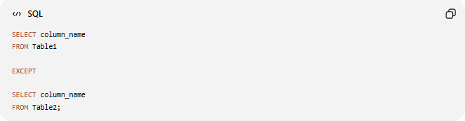
SELECT column_name
FROM Table1

EXCEPT

SELECT column_name
FROM Table2;

Example
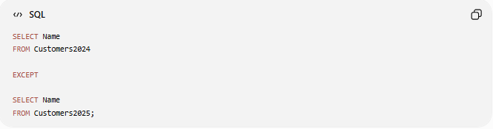
SELECT Name
FROM Customers2024

EXCEPT

SELECT Name
FROM Customers2025;

Result
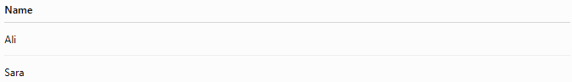
Name
Ali
Sara
Only records found in the first table are returned.

📊 Side-by-Side Comparison
# Source: AI Source: Provided by: [Data Path: Persons Table -> ID Column: 1, Name_En Column: Motasem Essam] -> From: [ChatGPT] on [6/11/2026]
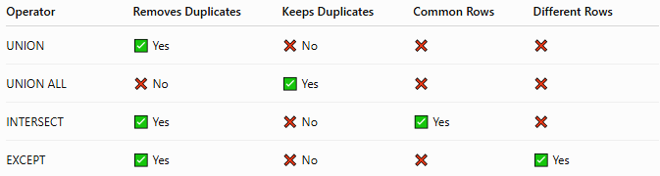
Operator | Removes Duplicates | Keeps Duplicates | Common Rows | Different Rows
UNION | ✅ Yes | ❌ No | ❌ | ❌
UNION ALL | ❌ No | ✅ Yes | ❌ | ❌
INTERSECT | ✅ Yes | ❌ No | ✅ Yes | ❌
EXCEPT | ✅ Yes | ❌ No | ❌ | ✅ Yes

🛠️ Complete Test Example

1️⃣ Create Tables
# Source: AI Source: Provided by: [Data Path: Persons Table -> ID Column: 1, Name_En Column: Motasem Essam] -> From: [ChatGPT] on [6/11/2026]
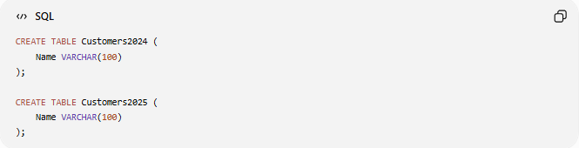
CREATE TABLE Customers2024 (
Name VARCHAR(100)
);

CREATE TABLE Customers2025 (
Name VARCHAR(100)
);

2️⃣ Insert Data
# Source: AI Source: Provided by: [Data Path: Persons Table -> ID Column: 1, Name_En Column: Motasem Essam] -> From: [ChatGPT] on [6/11/2026]
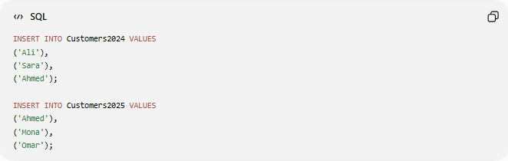
INSERT INTO Customers2024 VALUES
('Ali'),
('Sara'),
('Ahmed');

INSERT INTO Customers2025 VALUES
('Ahmed'),
('Mona'),
('Omar');

3️⃣ UNION
# Source: AI Source: Provided by: [Data Path: Persons Table -> ID Column: 1, Name_En Column: Motasem Essam] -> From: [ChatGPT] on [6/11/2026]
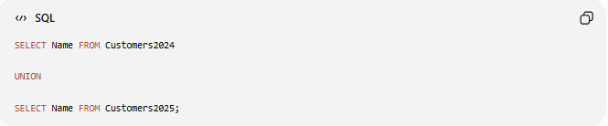
SELECT Name FROM Customers2024

UNION

SELECT Name FROM Customers2025;
Result
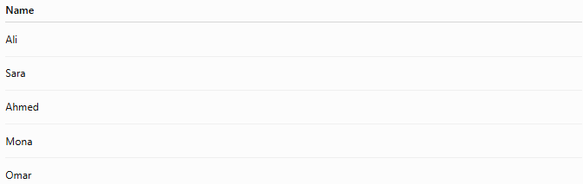
Name
Ali
Sara
Ahmed
Mona
Omar

4️⃣ UNION ALL
# Source: AI Source: Provided by: [Data Path: Persons Table -> ID Column: 1, Name_En Column: Motasem Essam] -> From: [ChatGPT] on [6/11/2026]
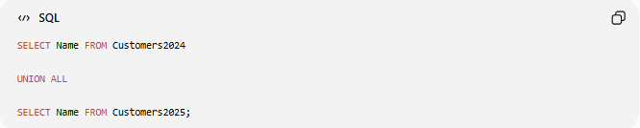
SELECT Name FROM Customers2024

UNION ALL

SELECT Name FROM Customers2025;
Result
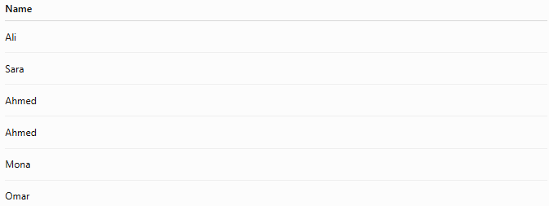
Name
Ali
Sara
Ahmed
Ahmed
Mona
Omar

5️⃣ INTERSECT
# Source: AI Source: Provided by: [Data Path: Persons Table -> ID Column: 1, Name_En Column: Motasem Essam] -> From: [ChatGPT] on [6/11/2026]
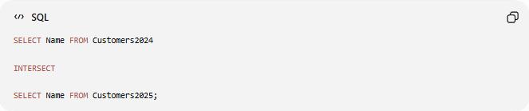
SELECT Name FROM Customers2024

INTERSECT

SELECT Name FROM Customers2025;
Result
Name
Ahmed

6️⃣ EXCEPT
# Source: AI Source: Provided by: [Data Path: Persons Table -> ID Column: 1, Name_En Column: Motasem Essam] -> From: [ChatGPT] on [6/11/2026]
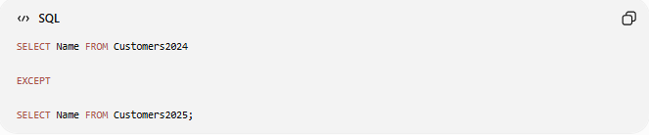
SELECT Name FROM Customers2024

EXCEPT

SELECT Name FROM Customers2025;
Result
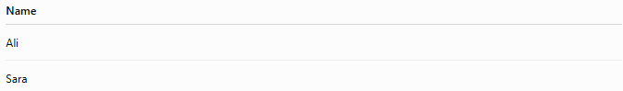
Name
Ali
Sara

Real Example

prepared commands

1️⃣ Create Tables
# Source: ScreenShot Source: Provided by: [Persons Table -> ID Column: 1, Name_En Column: Motasem Essam] -> Tool: [Automation Table -> ID Column: 16, Name_En Column: Screen Capture] -> From [Operating System: Wampserver64 -> phpmyadmin] on [6/11/2026]
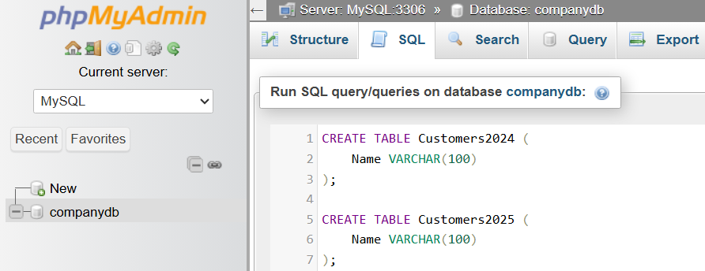
CREATE TABLE Customers2024 (
Name VARCHAR(100)
);

CREATE TABLE Customers2025 (
Name VARCHAR(100)
);
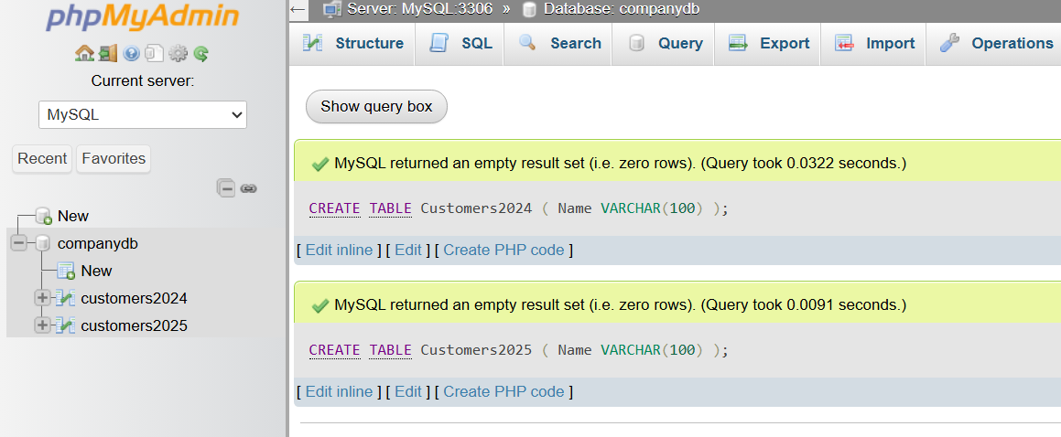

2️⃣ Insert Data
# Source: ScreenShot Source: Provided by: [Persons Table -> ID Column: 1, Name_En Column: Motasem Essam] -> Tool: [Automation Table -> ID Column: 16, Name_En Column: Screen Capture] -> From [Operating System: Wampserver64 -> phpmyadmin] on [6/11/2026]
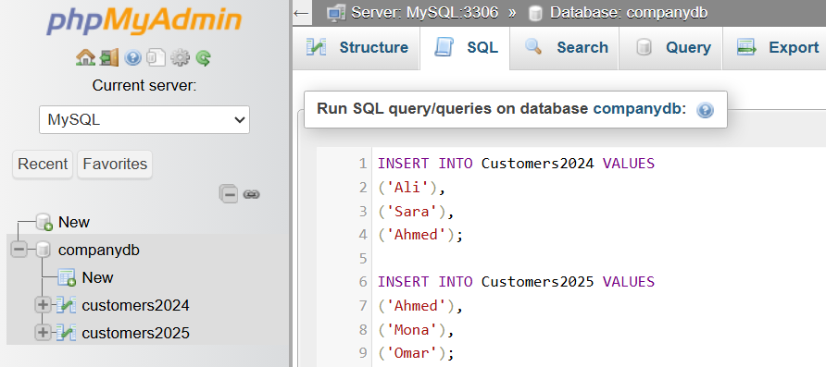
INSERT INTO Customers2024 VALUES
('Ali'),
('Sara'),
('Ahmed');

INSERT INTO Customers2025 VALUES
('Ahmed'),
('Mona'),
('Omar');
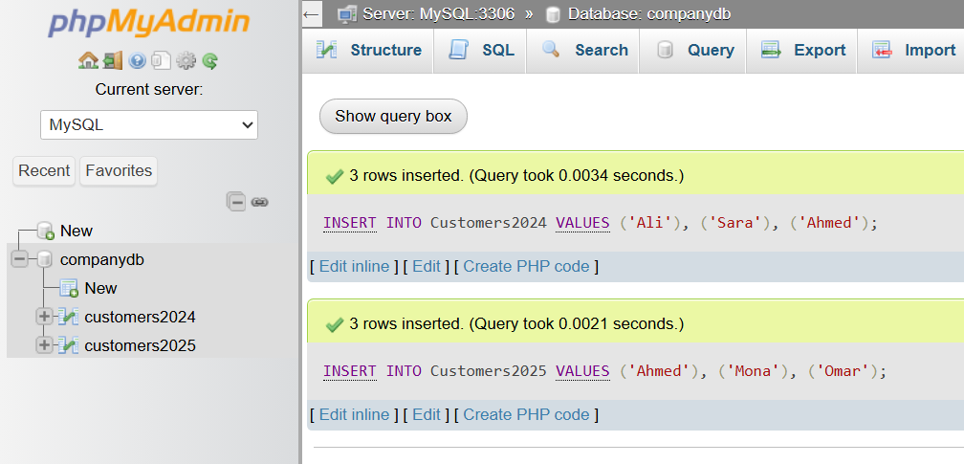

basic command

3️⃣ UNION
# Source: ScreenShot Source: Provided by: [Persons Table -> ID Column: 1, Name_En Column: Motasem Essam] -> Tool: [Automation Table -> ID Column: 16, Name_En Column: Screen Capture] -> From [Operating System: Wampserver64 -> phpmyadmin] on [6/11/2026]
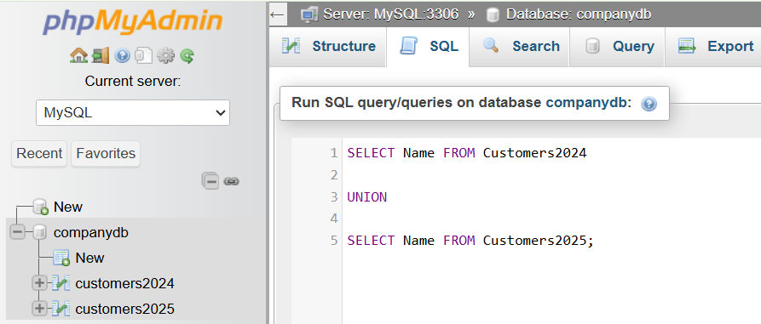
SELECT Name FROM Customers2024

UNION

SELECT Name FROM Customers2025;
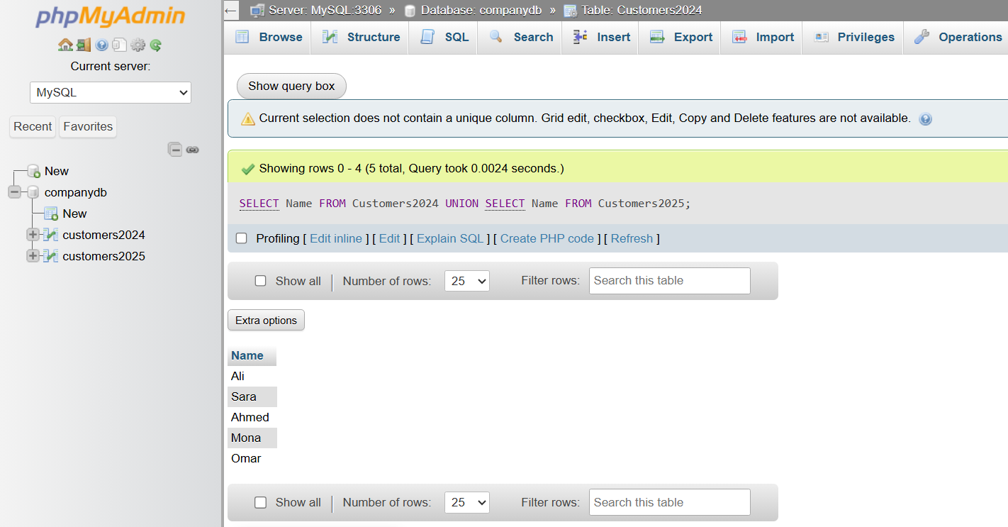

4️⃣ UNION ALL
# Source: ScreenShot Source: Provided by: [Persons Table -> ID Column: 1, Name_En Column: Motasem Essam] -> Tool: [Automation Table -> ID Column: 16, Name_En Column: Screen Capture] -> From [Operating System: Wampserver64 -> phpmyadmin] on [6/11/2026]
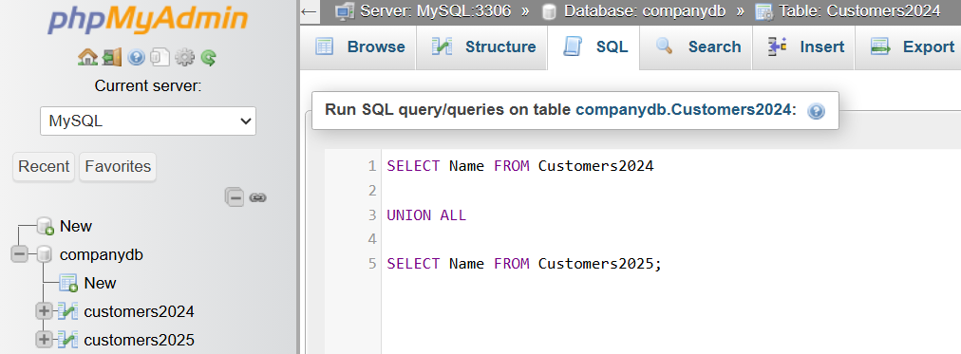
SELECT Name FROM Customers2024

UNION ALL

SELECT Name FROM Customers2025;
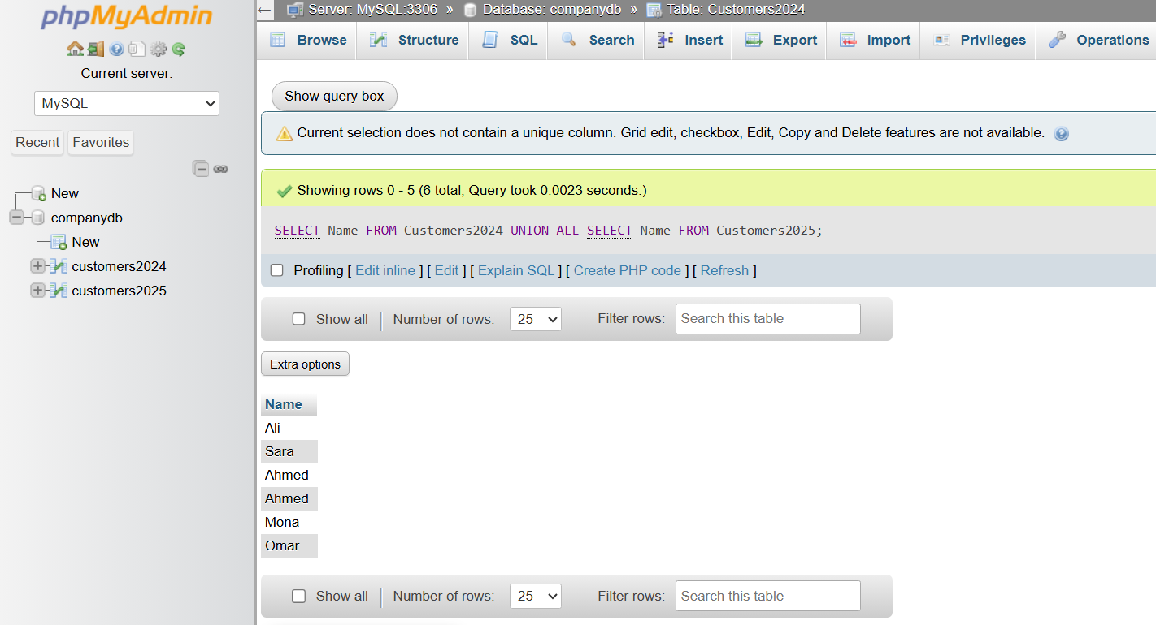

5️⃣ INTERSECT
# Source: ScreenShot Source: Provided by: [Persons Table -> ID Column: 1, Name_En Column: Motasem Essam] -> Tool: [Automation Table -> ID Column: 16, Name_En Column: Screen Capture] -> From [Operating System: Wampserver64 -> phpmyadmin] on [6/11/2026]
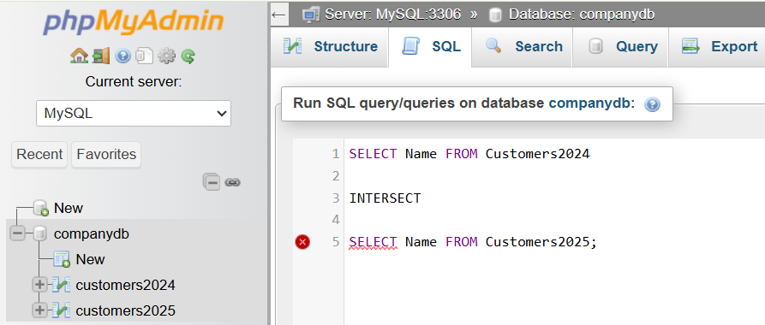
SELECT Name FROM Customers2024

INTERSECT

SELECT Name FROM Customers2025;
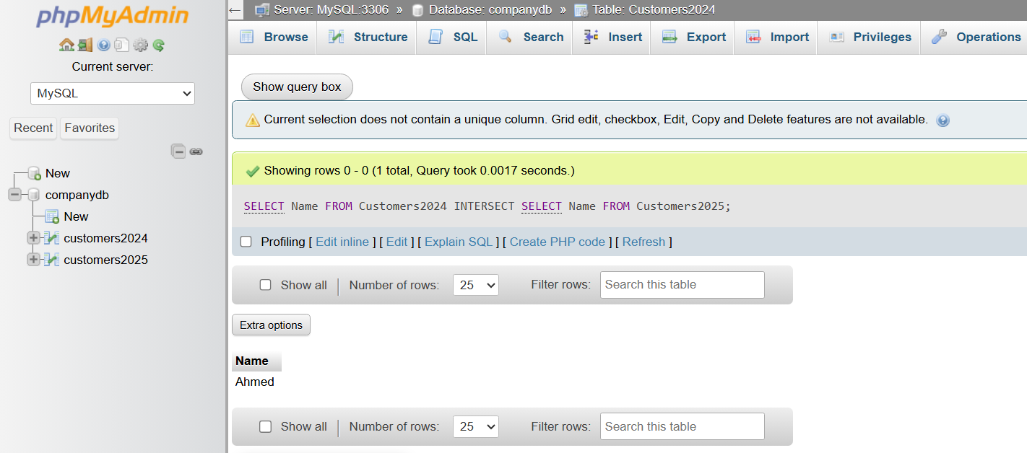

6️⃣ EXCEPT
# Source: ScreenShot Source: Provided by: [Persons Table -> ID Column: 1, Name_En Column: Motasem Essam] -> Tool: [Automation Table -> ID Column: 16, Name_En Column: Screen Capture] -> From [Operating System: Wampserver64 -> phpmyadmin] on [6/11/2026]
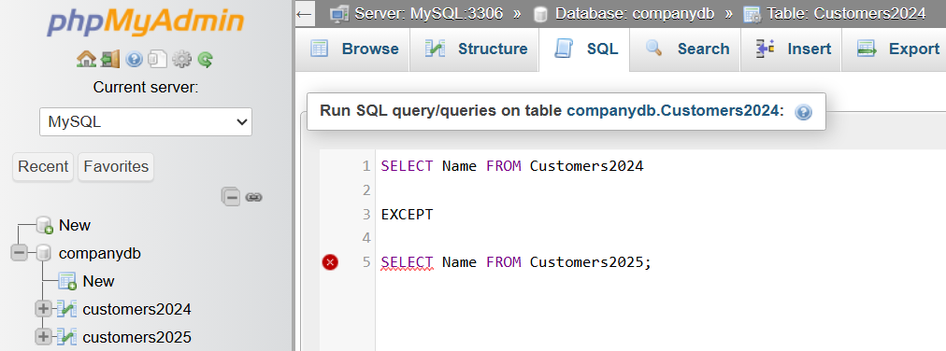
SELECT Name FROM Customers2024

EXCEPT

SELECT Name FROM Customers2025;
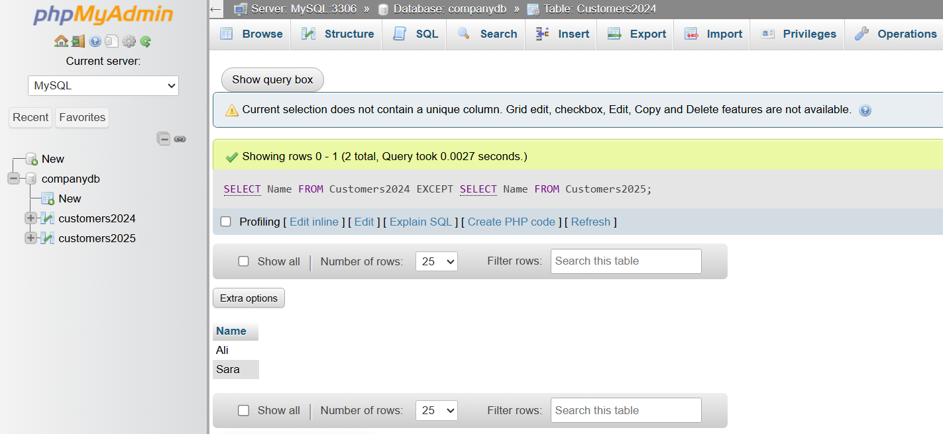

⚠️ Important Notes
# Source: AI Source: Provided by: [Data Path: Persons Table -> ID Column: 1, Name_En Column: Motasem Essam] -> From: [ChatGPT] on [6/11/2026]
- UNION automatically removes duplicate rows.
- UNION ALL is generally faster because it does not remove duplicates.
- INTERSECT and EXCEPT are not supported in all database systems (for example, older MySQL versions).
- Always use compatible columns in both queries.

🌍 Database Support
# Source: AI Source: Provided by: [Data Path: Persons Table -> ID Column: 1, Name_En Column: Motasem Essam] -> From: [ChatGPT] on [6/11/2026]
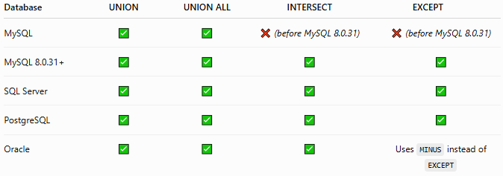
Database | UNION | UNION ALL | INTERSECT | EXCEPT
MySQL | ✅ | ✅ | ❌ (before MySQL 8.0.31) | ❌ (before MySQL 8.0.31)
MySQL 8.0.31+ | ✅ | ✅ | ✅ | ✅
SQL Server | ✅ | ✅ | ✅ | ✅
PostgreSQL | ✅ | ✅ | ✅ | ✅
Oracle | ✅ | ✅ | ✅ | Uses MINUS instead of EXCEPT

📊 UNION vs UNION ALL
# Source: AI Source: Provided by: [Data Path: Persons Table -> ID Column: 1, Name_En Column: Motasem Essam] -> From: [ChatGPT] on [6/11/2026]
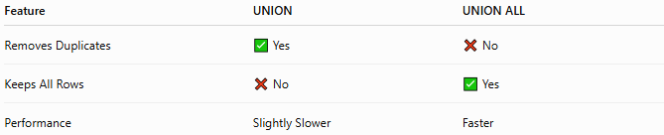
Feature | UNION | UNION ALL
Removes Duplicates | ✅ Yes | ❌ No
Keeps All Rows | ❌ No | ✅ Yes
Performance | Slightly Slower | Faster

🔢 SQL Set Operators Workflow
# Source: AI Source: Provided by: [Data Path: Persons Table -> ID Column: 1, Name_En Column: Motasem Essam] -> From: [ChatGPT] on [6/11/2026]
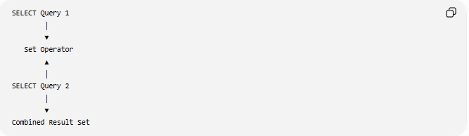
SELECT Query 1
│
▼
Set Operator
▲
│
SELECT Query 2
│
▼
Combined Result Set

🧠 Simple Analogy
# Source: AI Source: Provided by: [Data Path: Persons Table -> ID Column: 1, Name_En Column: Motasem Essam] -> From: [ChatGPT] on [6/11/2026]
Imagine two class attendance lists.
Class A

Ali
Sara
Ahmed
Class B

Ahmed
Mona
Omar
- UNION → Everyone from both classes (no duplicates).
- UNION ALL → Everyone from both classes (including duplicates).
- INTERSECT → Students present in both classes.
- EXCEPT → Students only in the first class.

🧭 Summary
# Source: AI Source: Provided by: [Data Path: Persons Table -> ID Column: 1, Name_En Column: Motasem Essam] -> From: [ChatGPT] on [6/11/2026]
SQL Set Operators combine the results of two or more SELECT statements into a single result set. The main set operators are UNION, UNION ALL, INTERSECT, and EXCEPT. They require each query to return the same number of compatible columns and are commonly used to merge data, remove duplicates, identify common records, and compare query results.

